April 8-9, 2022

The 2022 Pediatric Infectious Diseases Update, presented by the Division of Pediatric Infectious Diseases at Arkansas Children’s Hospital, is a two-day seminar held annually for family physicians, general practitioners, pediatricians, internists, pharmacists, and nurses.
The course provides in-depth discussion of infectious diseases and highlights new treatments for diseases seen frequently by practicing physicians.

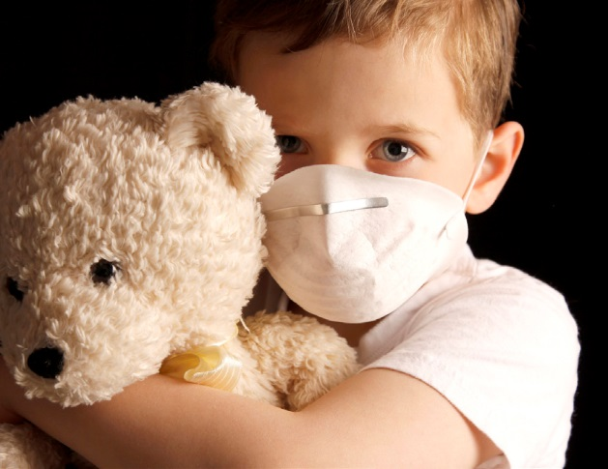

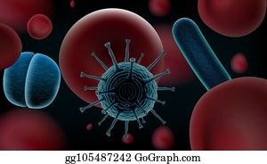

VIRTUAL EVENT

Big Cedar Lodge
Ridgedale, MO
36th
Pediatric Infectious Diseases Update

At the conclusion of the program, participants should be able to:
- Identify and manage neonates exposed to material infections such as CMV, TB, syphilis, and hepatitis C
- Determine the appropriate evaluation and management of children with osteomyelitis, bacterial respiratory infections, and chronic cough
- Evaluate immunocompromised patients for infections in an outpatient setting
- Plan up to date prevention measures and treatments for COVID-19

Accreditation
Accreditation: In support of improving patient care, this activity has been planned and implemented by the University of Arkansas for Medical Sciences and Arkansas Children’s Hospital. University of Arkansas for Medical Sciences is jointly accredited by the Accreditation Council for Continuing Medical Education (ACCME), the Accreditation Council for Pharmacy Education (ACPE), and the American Nurses Credentialing Center (ANCC), to provide continuing education for the healthcare team.

AMA Credit Designation Statement: The University of Arkansas for Medical Sciences designates this live activity for a maximum of 8.75 AMA PRA Category 1 Credits™. Physicians should claim only the credit commensurate with the extent of their participation in the activity.

ACPE Designation Statement: These knowledge based activities will provide pharmacists up to 8.75 contact hours or 0.87 CEU. CE credit information, based on verification of live attendance and completion of the program evaluation, will be provided to NABP within 60 days after the activity completion.

ANCC Credit Designation Statement: The University of Arkansas for Medical Sciences designates this live activity for a maximum of 8.75 ANCC contact hours. Nursing contact hours will be awarded for successful completion of program components based upon documented attendance and completion of evaluation materials.

AAPA Credit Designation Statement: The University of Arkansas for Medical Sciences has been authorized by the American Academy of PAs (AAPA) to award AAPA Category 1 CME credit for activities planned in accordance with AAPA CME Criteria. This activity is designated for 8.75 AAPA Category 1 CME credits. PAs should only claim credit commensurate with the extent of their participation.

MOC PART 2 Credit: Successful completion of this CME activity, which includes participation in the activity, with individual assessments of the participant and feedback to the participant, enables the participant to earn 8.75 MOC points in the American Board of Pediatrics’ (ABP) Maintenance of Certification (MOC) program. It is the CME activity provider’s responsibility to submit participant completion information to ACCME for the purpose of granting ABP MOC credit.

Registration
Registration for the conference will be online only and will be available until April 7, 2022. To register, please follow the link below.

36th Pediatric Infectious Diseases Update Conference

CONFERENCE AGENDA

Friday, April 8, 2022 – All Things COVID

8:30 – 8:45 Welcome & Housekeeping — Heather Young, MD, MSc

8:45 – 9:30 COVID-19 Update — Heather Young, MD, MSc

9:30 – 10:15 Congenital CMV — Archana Balamohan, MD

10:15 – 10:30 BREAK

10:30 – 11:30 Panel: Infants and Moms with Infections
Panelists:
NICU MD: Stephanie Korff, MD
Adult ID: Kristine Patterson, MD
Pediatric Infectious Disease: Heather Young, MD, MSc
11:30 – 12:15 Outpatient Management of Bacterial Respiratory Infections — Steven Dahl, MD

12:15 – 1:00 Neonatal HSV — Haleigh Shumate, APRN

1:00 LUNCH

Saturday, April 9, 2022 – Infectious Disease Update

8:30 – 8:45 Welcome & Housekeeping — Heather Young, MD

8:45 – 9:30 Osteomyelitis — Zain Alamarat, MD

9:30 – 10:15 Immunocompromised Patients in the Outpatient Setting — Bill Steinbach, MD

10:15 – 10:30 BREAK

10:30 – 11:30 Panel: Managing Chronic Cough
Panelists:
Allergy: Akilah Jefferson, MD, MSc
Pediatric Infectious Disease: Jessica Snowden, MD, MS
Pulmonary: Matthew Pertzborn, MD

11:30 – 12:15 Viral Respiratory Infections in Children — Pete Mourani, MD

12:15 – 1:00 Recurrent Staphylococcal Infections — Tim Onarecker, MD

1:00 – 1:15 Wrap-Up

1:15 LUNCH

UAMS/ACH Faculty

Zain Alamarat, MD Tim Onarecker, MD
Assistant Professor Assistant Professor
Pediatric Infectious Diseases Pediatric Infectious Diseases
UAMS College of Medicine UAMS College of Medicine
Arkansas Children’s Hospital Arkansas Children's Hospital

Archana Balamohan, MD Kristine L. Patterson, MD
Assistant Professor Associate Professor
Pediatric Infectious Diseases Internal Medicine Infectious Disease
UAMS College of Medicine UAMS College of Medicine
Arkansas Children’s Hospital
Matthew Pertzborn, MD
Steven Dahl, MD Assistant Professor
Assistant Professor Pediatric Pulmonary
Pediatric Infectious Diseases UAMS College of Medicine
UAMS College of Medicine Arkansas Children’s Hospital
Arkansas Children’s Hospital
Jessica Snowden, MD, MS
Akilah Jefferson, MD, MSc Division Chief and Professor
Assistant Professor Pediatric Infectious Disease
Pediatric Allergy UAMS College of Medicine
UAMS College of Medicine Arkansas Children’s Hospital
Arkansas Children’s Hospital
William “Bill” Steinbach, MD
Stephanie Korff, MD Department Chair, Department of Pediatrics
Assistant Professor UAMS College of Medicine
Pediatric Neonatology Arkansas Children’s Hospital
UAMS College of Medicine
Arkansas Children’s Hospital Heather Young, MD, MSc
Assistant Professor
Peter M. Mourani, MD Pediatric Infectious Diseases
President UAMS College of Medicine
Arkansas Children’s Research Institute Arkansas Children’s Hospital
Professor of Pediatrics, Critical Care
UAMS College of Medicine
Arkansas Children’s Hospital

Planning Committee

Heather Young, MD, MSc – Course Director Tim Onarecker, MD
Zain Alamarat, MD Haleigh Shumate, MSNc, APRN, CPNP-PC
Archana Balamohan, MD Jessica Snowden, MD, MS
Steve Dahl, MD Pat Brady, BSN, RN
Holly Maples, PharmD Lisa Chapple, RN
Caleb McMinn, PharmD Beck Thompson, BSN, RN, CPN

