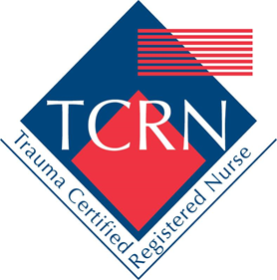
Trauma Certified Registered Nurse (TCRN) Review Course

September 20-21, 2018
0800-1700
Day 1: IDW 126
Day 2: Ed II B107

Contact Hours Awarded: Up to 14.75

To Register contact Kelly Urban: klurban@uams.edu

Accreditation Statement
In support of improving patient care, University of Arkansas for Medical Sciences is jointly accredited by the Accreditation Council for Continuing Medical Education (ACCME), the Accreditation Council for Pharmacy Education (ACPE), and the American Nurses Credentialing Center (ANCC) to provide continuing education for the healthcare team.
American Nurses Credentialing Center (ANCC)
The University of Arkansas for Medical sciences designates this live activity for a maximum of 14.75 ANCC contact hours. Nursing contact hours will be awarded for successful completion of program components based upon documented attendance and completion of evaluation materials.

